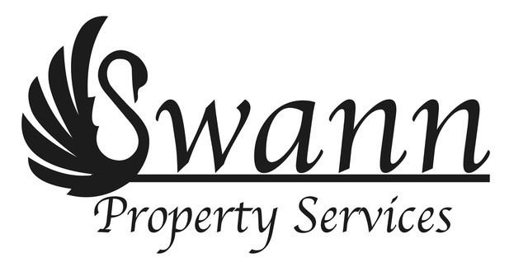
Letting and Management agreement
Between

[Name of Landlord]

And
Swann Services (Property) Limited trading as Swann Property Services

Relating to
[Property address]
This agreement is made the day of 20[ ] Between [Name of Landlord] of [Address of Landlord] (the ‘Owner’) and Swann Services (Property) Limited of Unit 54, The Grand Mill, 132 Sunbridge Road, Bradford BD1 2PF (the ‘Letting & Managing Agents’)
Now it is agreed as follows:
- The Owner appoint the Managing Agents to be their managing agents in respect of [ ] registered at HM Land Registry with title number [ ] (the ‘Property’) and to perform the duties set out below in accordance with the following terms:
- The Letting & Managing Agents agree with the Owner:
  - Where required, to advertise and market the Property through the main property platforms, prepare property particulars, be the first point of contact with suitable applicants, co-ordinate viewings with suitable applicants, keeping you regularly updated throughout the process, helping you to identify and resolve any gaps before you’re lawfully able to let the Property and preparing the lettings paperwork including the tenancy agreement with the successful applicant;
  - To collect all rents from time to time payable to the Owners in respect of the Property or any part of it or to direct tenant to pay you directly;
  - To collect all charges, fees or other sums (other than rent) from time to time payable to the Owner in respect of the Property or any part of it which the Owner shall specify to the Letting & Managing Agents in writing from time to time;
  - To notify the Owner of every occasion when any sum due by way of rent or other charge, fee or sum within clause 2.3 above has been outstanding for 28 days;
  - To discharge the following liabilities of the Owner in respect of the Property and to pay the following sums in respect of it but only to the extent that the Letting & Managing Agents are able to do so out of the sums collected and retained by them pursuant to clauses 2.2 and 2.3 above:
    - the cost of maintaining the Property in accordance with this agreement;
    - any sums reasonably necessary to be expended in respect of the Property in an emergency in accordance with the principles of good estate management; and
    - the management fees payable pursuant to clause 3 below.
  - To inspect the state of repair and condition of the Property as often as may be reasonably necessary to identify all reasonably necessary works of repair and maintenance of the Property;
  - Except in case of emergency to notify the Owner as often as may be reasonably necessary of all reasonably necessary works of repair and maintenance of the Property and estimated to cost more than £100 and to seek the Owner’s instructions as to the carrying out of such works and to advise the Owner in connection with those works and upon receipt of such instructions to instruct competent contractors to carry out the works and to supervise the work of such contractors;
  - In respect of all reasonably necessary works of repair and maintenance of the Property not within clause 2.7 above to instruct competent contractors to carry out the works and to supervise the work of such contractors Provided always that the Letting & Managing Agents will be liable under this clause only to the extent that they are able to pay for such works out of the sums collected and retained by the Letting & Managing Agents pursuant to clauses 2.2 and 2.3 above;
  - To notify the Owner immediately of any occasion when the Managing Agents are unable to discharge any liability of the Owner or to pay any sum pursuant to clause 2.5 above or are unable to instruct contractors in respect of works within clause 2.8 above on account of insufficiency of the sums collected and retained by them pursuant to clauses 2.2 and 2.3 above;
  - To prepare statements of account for each month in each year, such statements to show all receipts and all expenditure by the Managing Agents in respect of the Property for the relevant month;
  - To serve all statements of account pursuant to clause 2.10 above on the Owner as soon as available, and to advise the Owner on what sums should be retained by the Managing Agents in order to enable them to meet their obligations under clauses 2.5 and 2.8 above and to remit to the Owner such part of the sums collected pursuant to clauses 2.2 and 2.3 above;
  - To maintain all reasonably necessary records;
  - To notify the Owner of any apparent breach of any tenancy agreement of the Property or any part of it or of any unlawful or suspicious acts or omissions or circumstances relating to the use or occupation of the Property or any part of it and in all such cases to seek instructions from the Owner before demanding or accepting rent or other sums due under any relevant lease or otherwise treating such lease as subsisting;
  - Without prejudice to the generality of the above to comply with all reasonable instructions of the Owner from time to time in connection with the management of the Property or any part of it; and
  - Without prejudice to the generality of the above to manage the Property on behalf of the Owner in accordance with the principles of good estate management.
- The Owner agrees with the Letting & Managing Agents to pay to the Letting & Managing Agents a tenant finder’s fee of £100 and management fee of 10% of the rents receivable by the Owners in respect of the Property as quantified at the commencement of each month, such fee to be paid to the Managing Agents in arrears on the day at the end of the relevant month.
- This agreement may be determined by either party giving to the other at any time not less than one month's written notice expiring at any time.
- Within 21 days of this agreement being determined, the Managing Agents agree to prepare and serve on the Owner a statement of account showing all receipts and expenditure in respect of the Property from the date of the last statement of account prepared under clause 2.10 above up to the date of such determination.
- The Letting & Managing Agents may assign the benefit of this agreement to the Lettings & Managing Agents and Pink Elephant Sales & Lettings Ltd (“Pink Elephant”) to enable the Letting & Managing Agents to better perform its obligations under this agreement and so that The Letting & Managing Agents and Pink Elephant become joint managing and lettings agents for the Property providing no further costs are incurred by the Owner in such assignment.

The Owner acknowledge that the Letting & Managing Agents may, as the case may be and from time to time, receive a request from HMRC to disclose information about the Owner’s income from the Property and the Owner consents to the disclosure of such information as may be lawfujlly required from HMRC from time to time to enable the Letting & Managing Agents to discharge their legal obligations.

Signed by or on behalf of the Owner

Signed by or on behalf of the Letting & Managing Agents

